

**NOVEL IDEA**

**LIBRARY**

DEVELOPER GUIDE

**PROJECT:** NOVEL IDEA LIBRARY

**GROUP MEMBERS:**

|  |  |
| --- | --- |
| **GROUP MEMBERS** | **ENROLLMENT NO.** |
| **RIDA FATIMA** | **STUDENT1107273** |
| **MEHAK NASIR** | **STUDENT1105268** |
| **MUHAMMAD ZAIN** | **STUDENT1106863** |
| **BILAL MISBAH** | **STUDENT1107157** |

**FACULTY:** AATIKA LIAQUAT

**BATCH CODE:** 1805C1

**CURRICULUM:** 6673

**SEMESTER:** HDSE-II





**CHAPTER 1**

**HOME PAGE**

**HOMEPAGE**

The homepage shows a brilliant header along with a sober background look giving our readers a pleasant effect on the eyes and soul. Extensive work has been done on other pages too.



**HEADER**

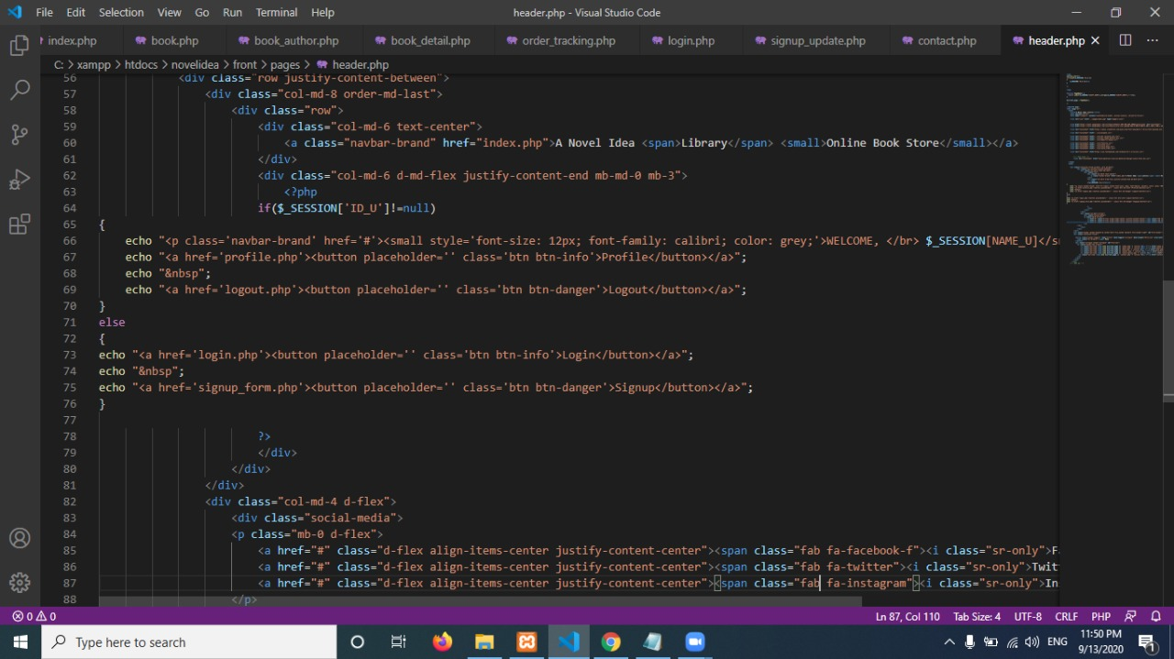



**CHAPTER 2**

**CATEGORY PAGES**

**BOOKS CATEGORY PAGE**

The Website shows the category page including all the books and their genres. Other than that, we show all the new releases and stores of volumes shared on our website.

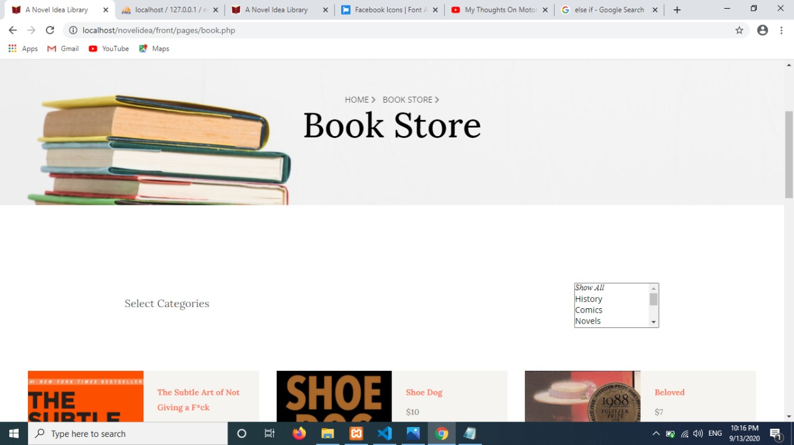



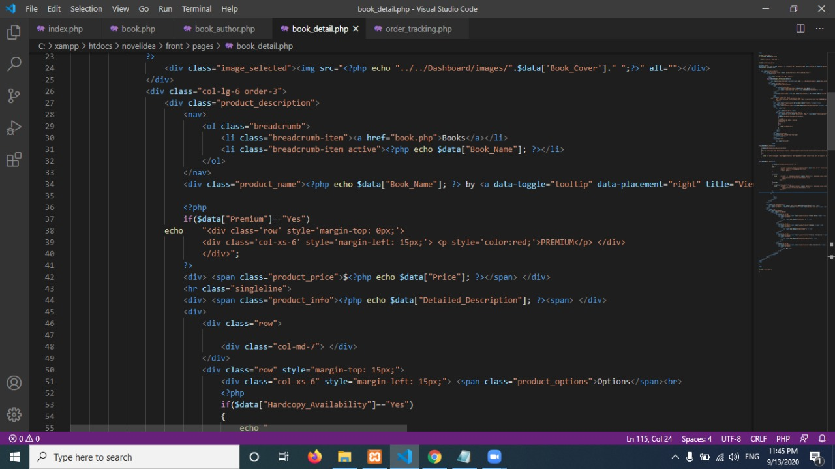

The bonus is that the person can not only view books through genres but can also filter through Authors favorite select.

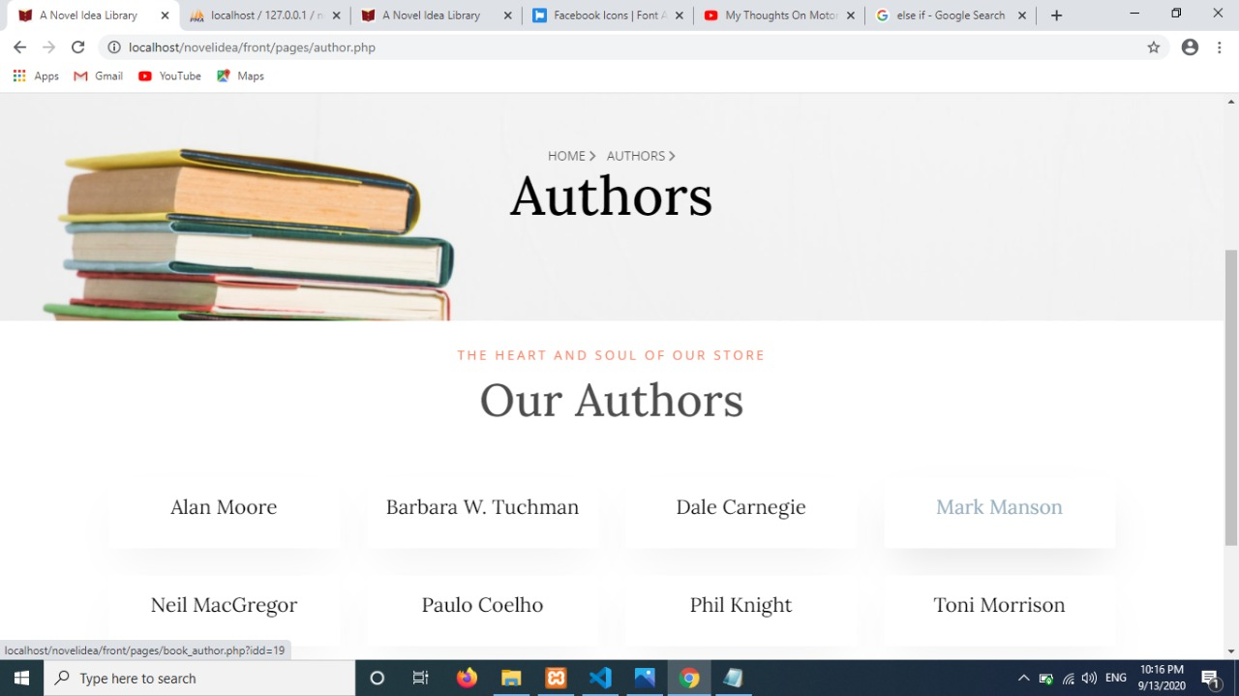

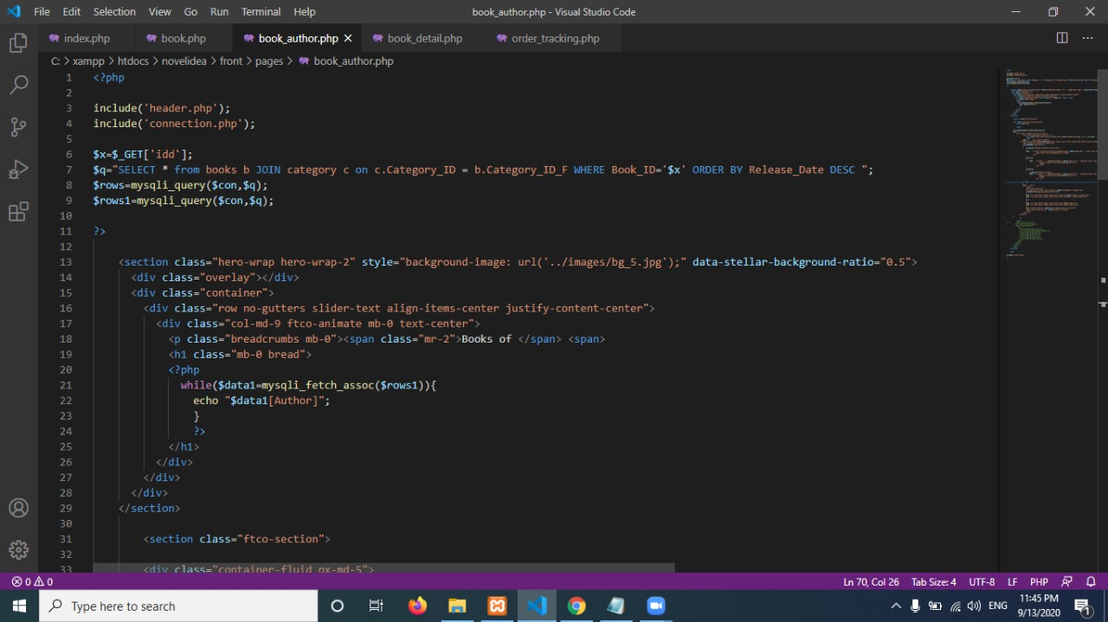



**CHAPTER 3**

**CONTACT US**

**CONTACT US PAGE**

You can contact us through either call or email or can visit our nearest branch for further details.

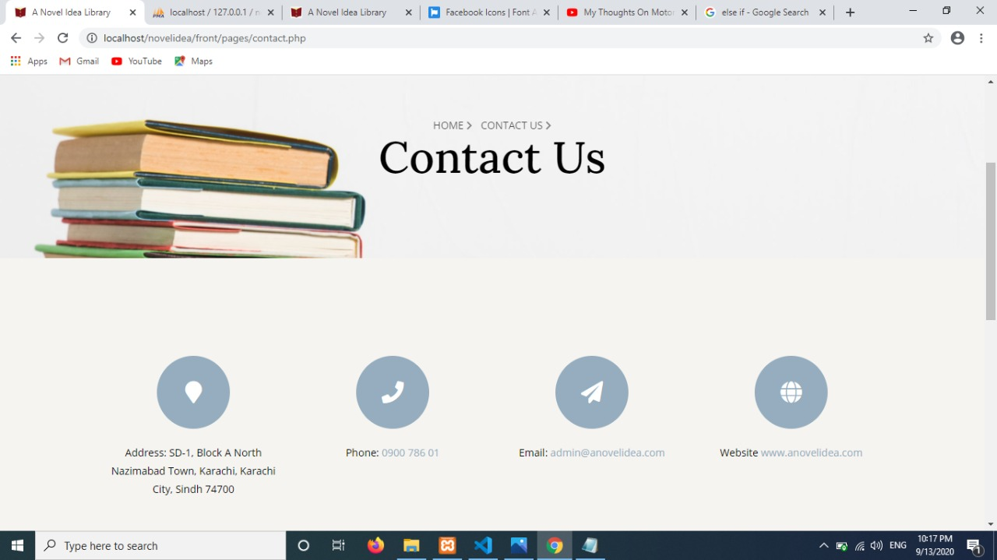

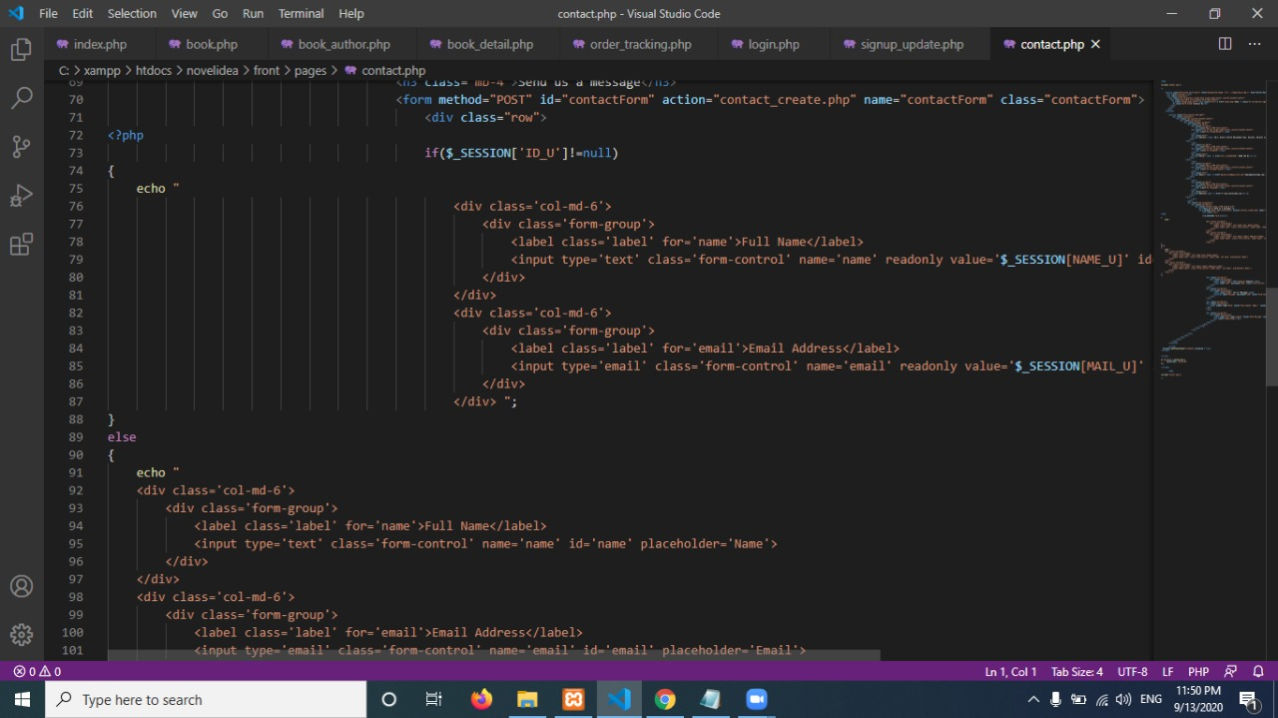



**CHAPTER 4**

**SIGN UP &**

**LOG IN**

**SIGN UP PAGE**

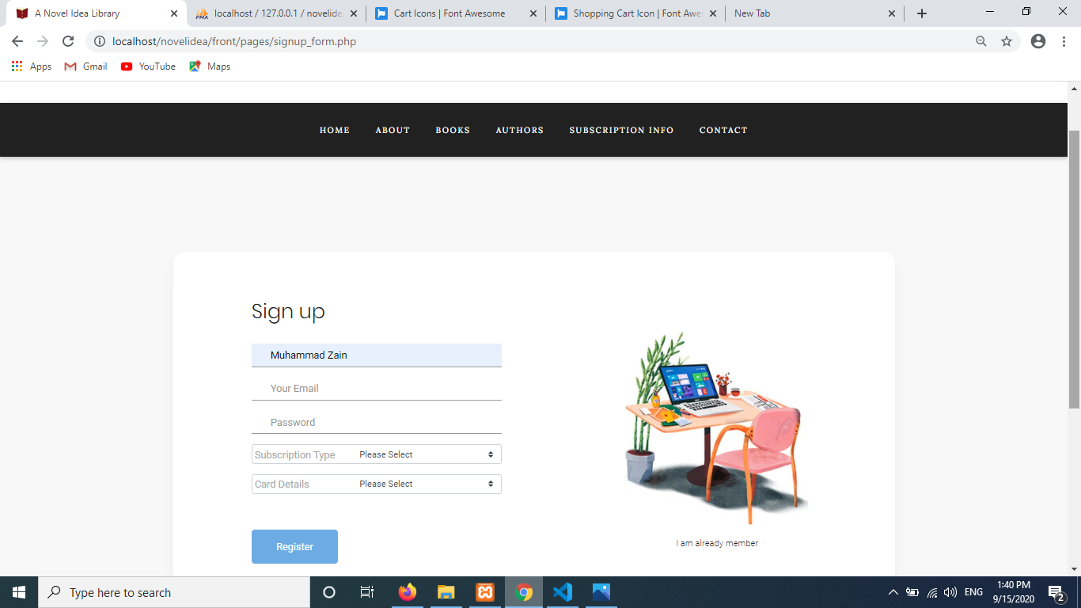

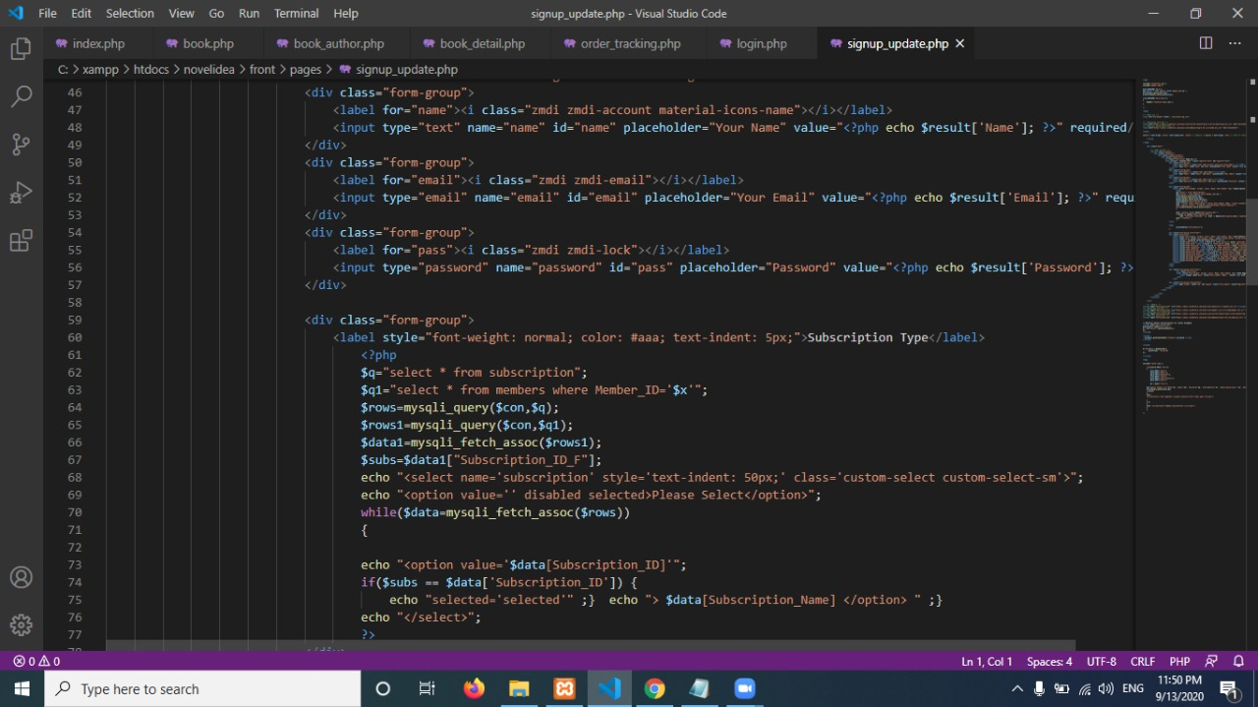

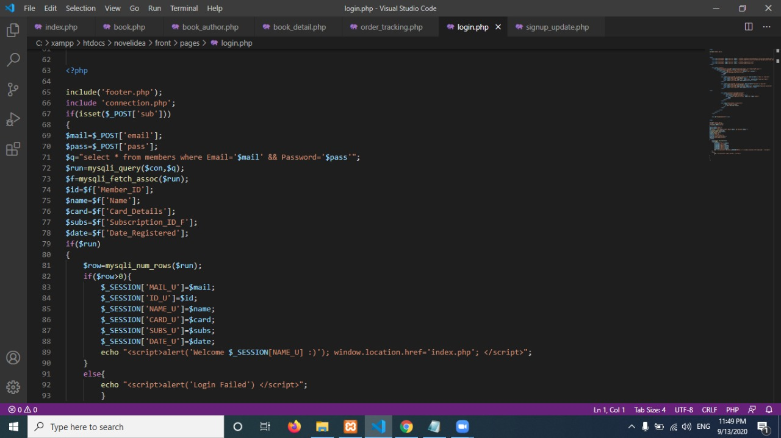



**CHAPTER 5**

**PACKAGE DETAIL**

**PACKAGE DETAILS**

The website offers a great number of packages to the customers, each package has its own perks. You can further gain information through the Problem statement specified in the Documentation.

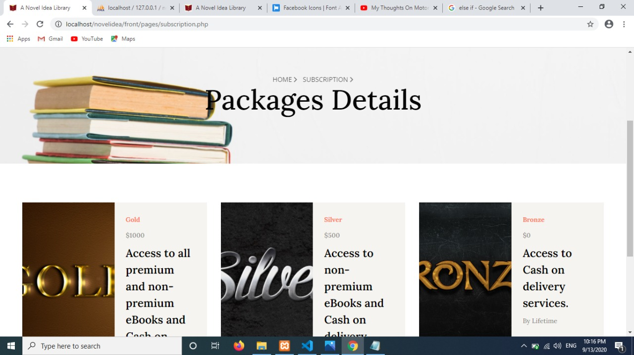



**CHAPTER 5**

**ADD TO CART**

**ADD TO CART PAGE**

This includes a brief work concept of books being add to cart. It includes a section of Active Orders, along with whether the orders have been successfully delivered or not.

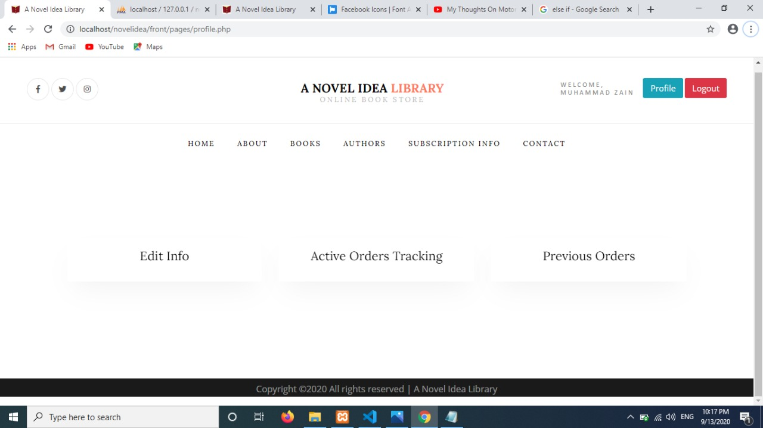

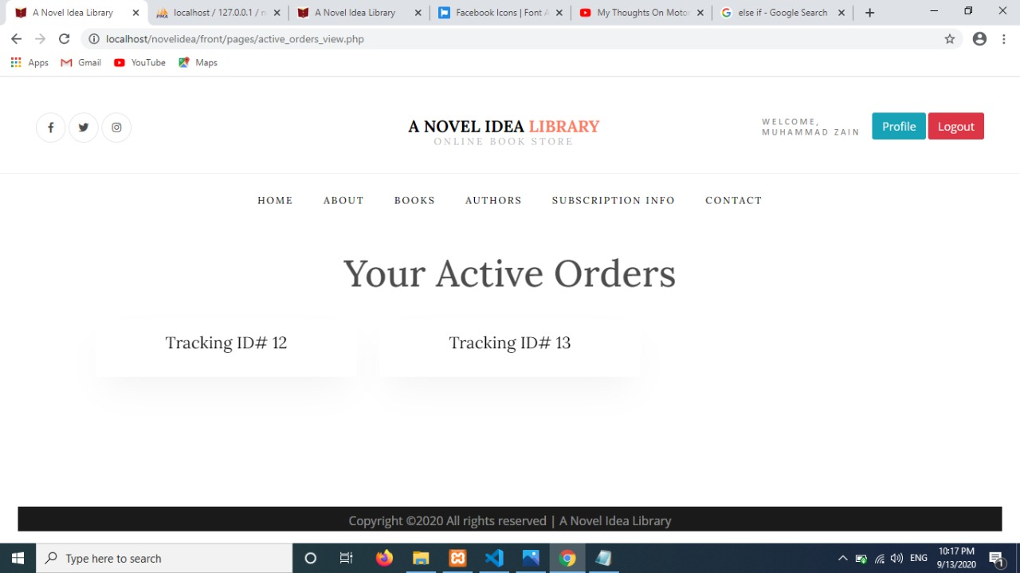

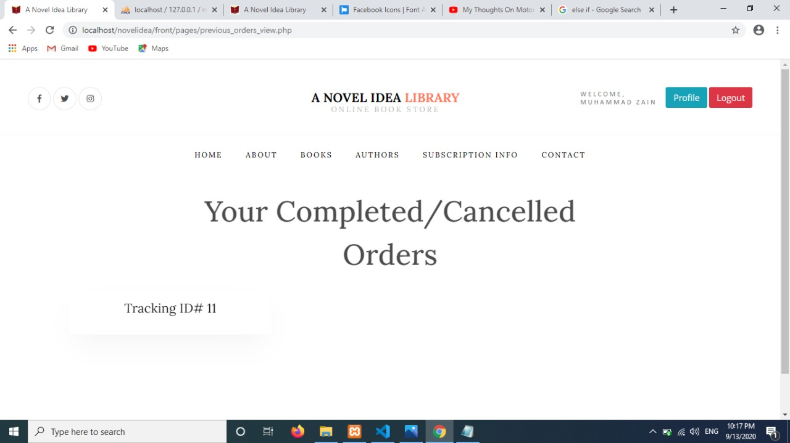

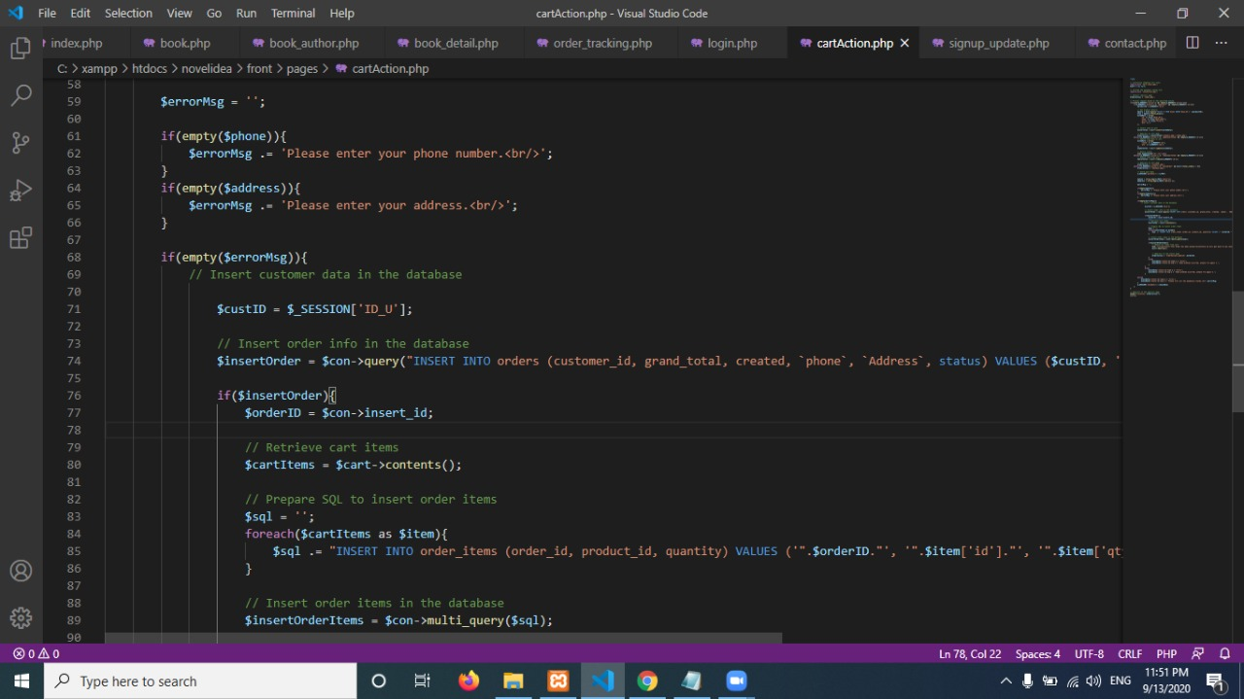

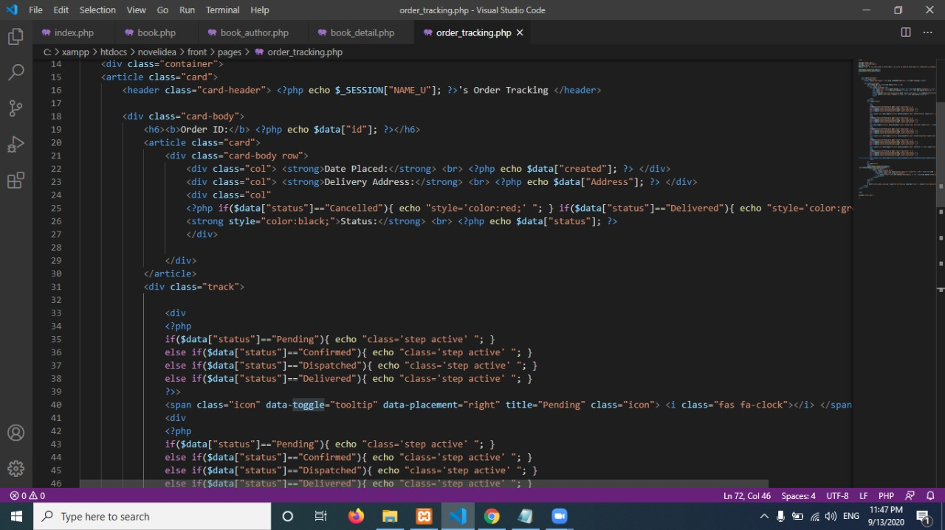

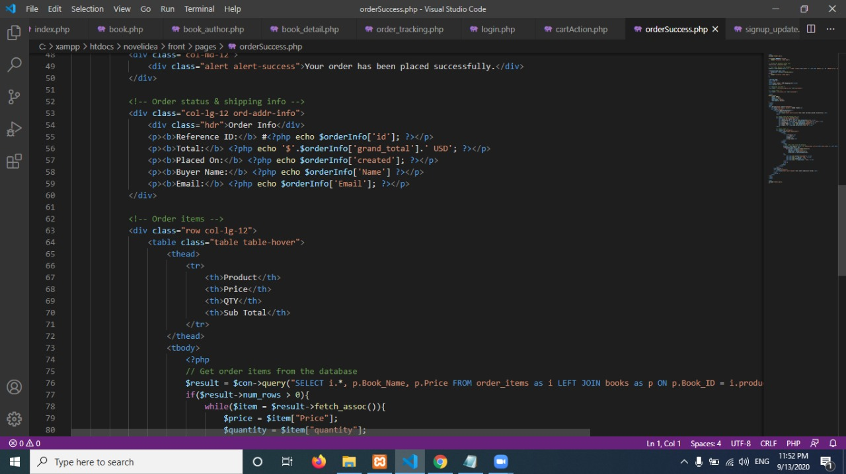



**CHAPTER 5**

**DASHBOARD**

**DASHBOARD**

The dashboard consists of various navigations like Edit, Delete, Insert & Update Admins, Categories, Subscriptions, Books, Members etc.

